EVENTI
Use Case Diagram

Submitted to:

Prof. Ma. Rowena C. Solamo
Faculty Member
Department of Computer Science
College of Engineering
University of the Philippines, Diliman

Submitted by:
[List of Members in Alphabetical Order]

In partial fulfillment of Academic Requirements
for the course
CS 191 Software Engineering I
of the
1st Semester, AY 2014-2015
Unique Reference:
The documents are stored in the [GitHub Repository Link].
[File Reference in GitHub, preferably link.]

Document Purpose:
[What is the purpose of the document?]

Target Audience:
[Place here the target audience.]

Revision Control

History Revision:
Revision Date | Person Responsible | Version  Number | Modification
MM/DD/YY | Dimaano, Diego  Lopez, Matthew  Torres, Jacob | 1.0 | Initial Document.

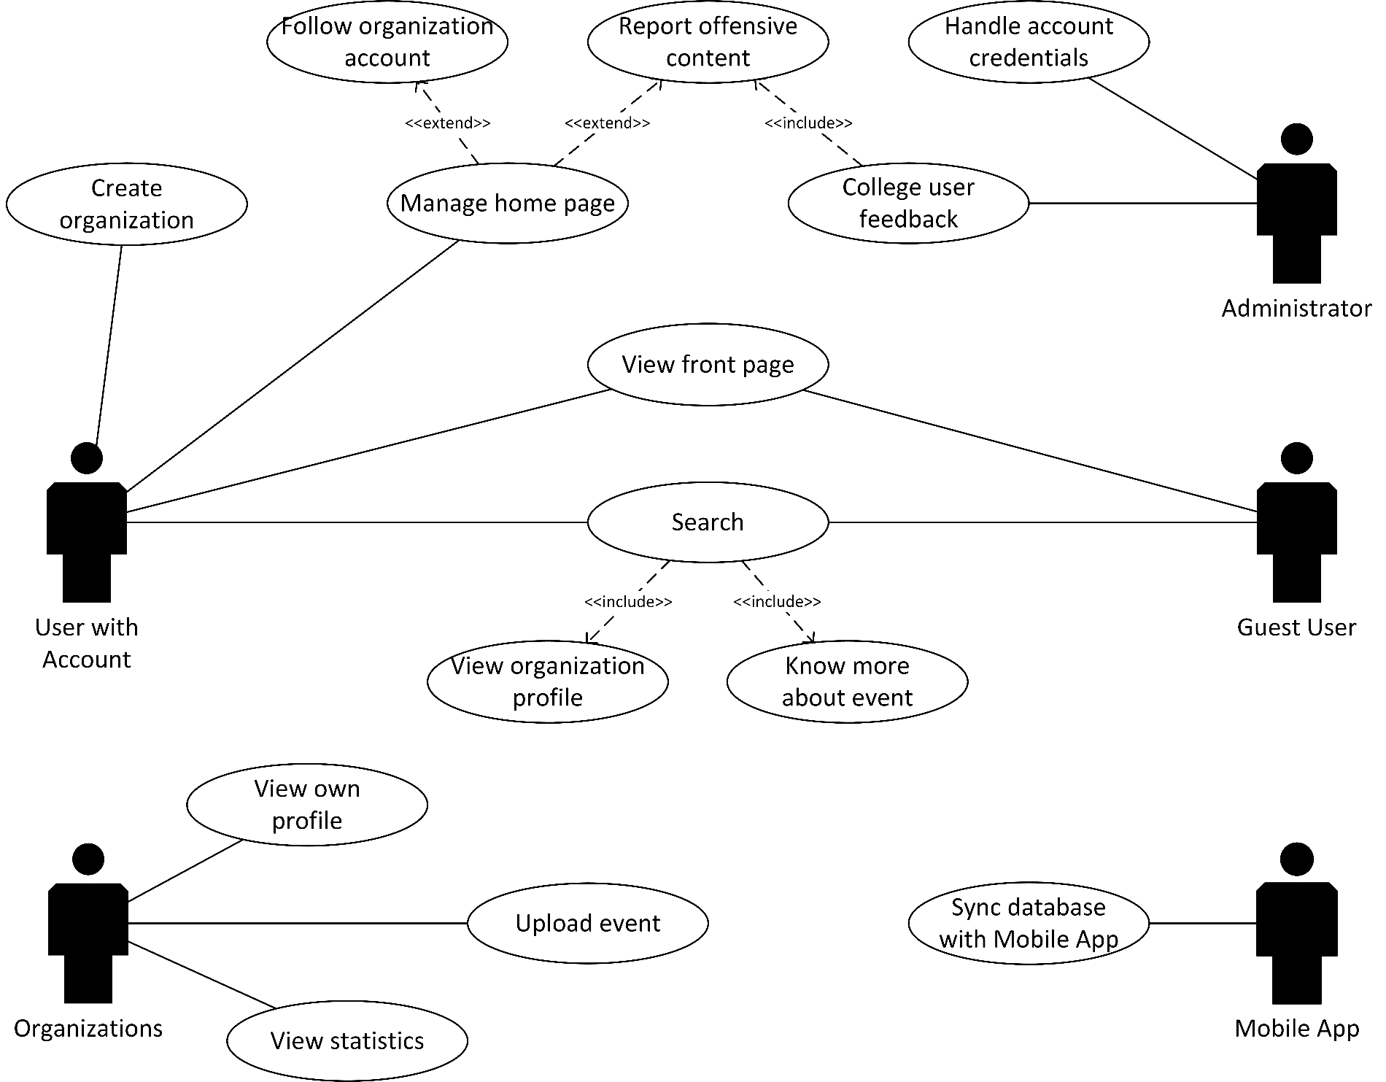
System Name: Events Sharing Web System

Description: [Brief Description of the System in 3-7 sentences.]

Use-Case Diagram:

List of Actors:
Actors | Description
Club Staff | [Write the description of the actor. 3-5 sentences]
Coach | [Write the description of the actor. 3-5 sentences]

List of Use-cases:
Use-Case | Description
Use-Case 1.0 Maintain Athlete Record | [Write the description of the actor. 3-5 sentences]
Use-Case 1.1 Add Athlete Record | [Write the description of the actor. 3-5 sentences]

